Analysis about accidents caused by weather and road conditions

# **Introduction/Business Problem**

There are so many vehicles that we can see around us. According to the increase of vehicles many car accidents have been indicated since then. So, using data which contains many information about car accident, we are going predict the possibility of car accident according to many conditions. And I will focus more on solving with relationship between accidents according to road conditions.

# **Data**

This data is provided by Coursera. It contains Collisions that happened in Seattle City. The main data section we are going to use is Weather road condition. Weather condition includes factors such as 'Clear','Raining','Overcast','Snowing' etc. Road Condition includes factors such as 'Dry','Wet','Unknown','Ice' etc.

# **Methodology**

I am planning to analyze the data according to the portion of each components. First I am going to use value_counts() function and to_frame() function to make a new data frame that contains how many accidents happened according to each weather and road condition components. According to that data, I am going to make a pi chart to visualize the data. After that, we are going to analyze the results.

# **Result**

Making a new data frame gave these results.

1. Accidents according to road conditions



1. Accidents according to weather

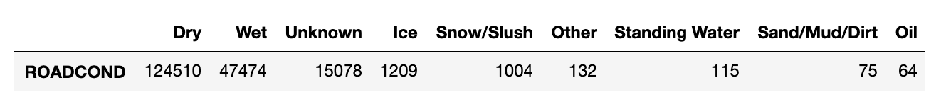

Since it is difficult to visualize, I decided to use pi-chart for more convenience. And the results showed as below.

1. According to road conditions.

Dry condition showed the most percentage 65.7% of accidents. The second was wet condition with 25.1% and the third was Unknown 8.3% and the rest was showing a small percentage.

1. According to Weather conditions.

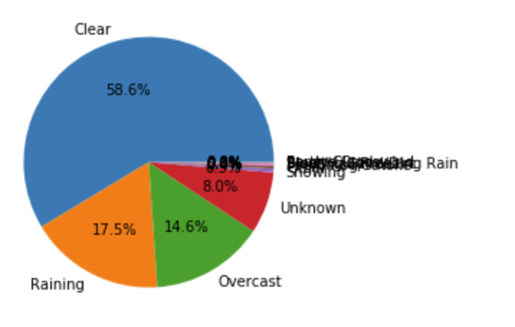

Clear condition showed the most percentage 58.6% of accidents. The second was Raining condition with 17.5% and the third was Overcast 14.6% and the fourth was Unknown rating 8.0% and rest was showing a small percentage.

# **Discussion**

As we can see, Raining and wet condition each rated 2nd place in the data frame. Which we can interpret this to think that wetness of the ground had influences on the probability of accidents. But we can’t conclude that it causes the most affect. Since, dry and clear sky was the most percentage in the result. So we can say the cause of accident according to the weather isn’t that big.

# **Conclusion**

The weather condition did not give that much of an influence as much as I expected. However, in the aftermath I believe if we compare other city’s data we could see if it causes more or less influences.

I believe there are more conditions we can try out and see the relationship between the accident.